**COLONIAL NEWS**

Health Committee Newsletter SEPTEMBER 2023

Welcome to the Albert Gallatin School District Health Committee’s monthly newsletter. Each month this publication will provide our district with health and fitness information. Our goal is for our students, families, and staff to use this information to make healthy decisions and to live a healthy active lifestyle.

**Mindfulness**

Feeling stressed? Here are some ways to quickly calm down.

* Count Breaths – sit comfortably, back straight, eyes closed. Count once for each breath in, once for each breath out. When you get to 10, start again.
* Take a 5-10-minute walk. Focus on what it feels like as your feet touch the ground.
* Eat Mindfully – Get a few bites of food. Take a few moments just to eat. Don’t do anything else at the same time.
* Be Mindful of Your Body – sit comfortably, back straight. Or lie down. Close your eyes. Notice what’s happening to your body. Are your shoulders tight? Are you breathing in fully? Try 1-5 minutes to start.

Mindfulness means giving your full attention to what’s happening right now. Staying in the present moment gives you more awareness of what’s happening in your mind and body.

(adapted from Source: EdLogics)

For more information visit nccih.nih.gov/health/tips/stress

# September is National Food Safety Education Month

Each September, in recognition of [National Food Safety Education Month](https://www.fda.gov/food/consumers/food-safety-education-month), health educators and consumers have focused on the most effective ways to avoid Foodborne illness, also called food poisoning. According to the Centers for Disease Control and Prevention, 48 million persons — or 1 of every 6 people get foodborne infections each year.

Foodborne illness is unpleasant and potentially dangerous for everyone, but you can avoid getting sick by following simple steps – Clean, Separate, Cook, Chill, and if at a higher risk, then possibly avoiding certain foods.

1. Clean: Wash your hands before and after handling food and wash your cutting boards, countertops, dishes, and utensils with hot soapy water. Rinse fresh fruits and vegetables under running tap water.
2. Separate: Separate raw meat, poultry, seafood, and eggs from other foods in your grocery cart. Use separate cutting boards for fresh produce and raw meat, poultry, seafood.
3. Cook: Use a food thermometer to ensure that raw meat, poultry, seafood, and egg products are cooked to a safe minimum internal temperature to destroy any harmful bacteria.
4. Chill: Refrigerate or freeze meat, poultry, eggs, seafood, and other perishables within 2 hours of cooking or purchasing. Refrigerate within 1 hour if the temperature outside is above 90° F. Never thaw food at room temperature, such as on the countertop.

(adapted from Source: www.fda.gov)

For more information visit

[www.fda.dot.gov](http://www.fda.dot.gov)

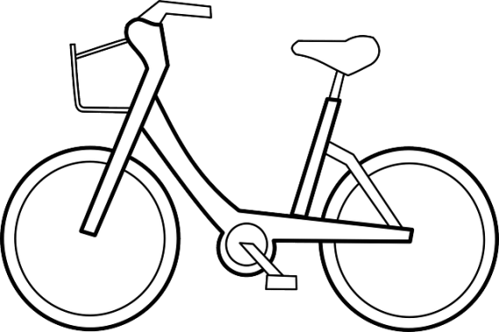

Prepared by Lisa Sumey, Central Office Secretary

**Recipe of the Month**

## Apple-Cinnamon Snack Cake

**Ingredients**

* 1 large apple, diced very small
* 1 Tbsp coconut sugar or brown sugar
* 1 1/2 tsp cinnamon, divided
* 1 cup unsweetened applesauce
* 1 large egg
* 6 Tbsp avocado or vegetable oil
* 1/4 cup honey or maple syrup
* 1/2 cup milk (any kind)
* 2 tsp vanilla extract
* 1 1/2 cups "quick" (instant) oats not regular rolled oats
* 1 cup whole wheat flour all-purpose or gluten-free blend
* 1 1/2 tsp baking powder
* 1/4 tsp salt

**Instructions**

* 1. Preheat oven to 350 degree. Grease a 9-inch square cake pan then line partially with parchment paper (This just makes it easier to remove from the pan but you can skip that step if you’d prefer.)
  2. Add diced apple, coconut or brown sugar, and a 1/4 tsp of cinnamon to a bowl then mix to combine. Set aside.
  3. In a large bowl, whisk together applesauce, egg, oil, honey or maple syrup, milk, and vanilla. Using a spoon or rubber spatula, stir in the remaining 1 1/4 tsp cinnamon and the rest of the dry ingredients. Mix until just combined then stir in the diced apple mixture.
  4. Spread cake batter evenly in your prepared pan and sprinkle on a pinch of extra oats, if you'd like. Bake until golden brown around the edges and a toothpick inserted into the center of the pan comes out clean, 25 to 30 minutes.
  5. Cool completely then cut into 12 squares.

   
  
  
  
   
  
 

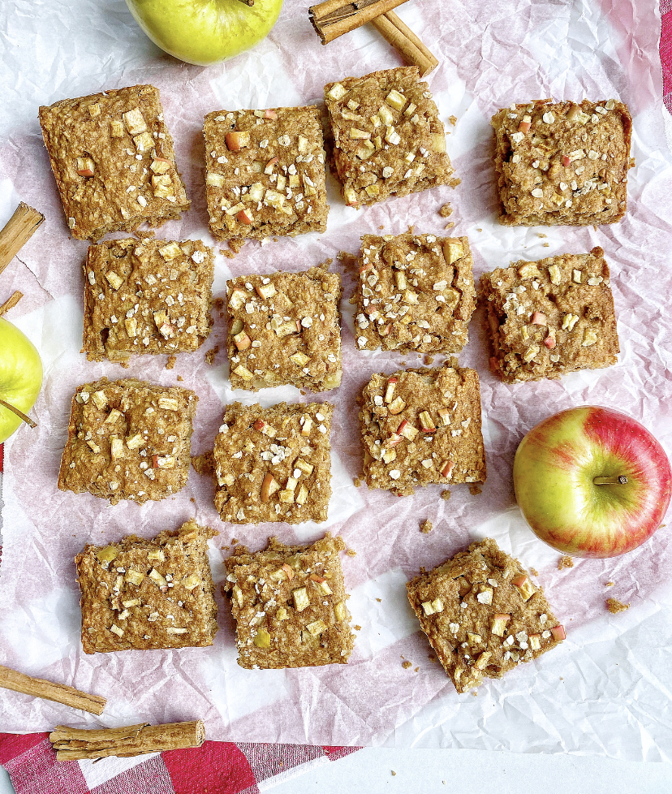

DID YOU KNOW?

* Apples float in water because 25% of their volume is actually air.
* Apple trees take 4-5 years to produce their first fruit.
* Apples will ripen six to ten times faster at room temperature than if they were refrigerated.
* It takes about 36 apples to create one gallon of apple cider.

